Safehub: User Manual

Table of Contents
Part 1: Getting Started
Part 2: Account Access
Part 3: Home Dashboard
Part 4: AI Chatbot Support
Part 5: Counseling Appointments
Part 6: Mood Tracking
Part 7: News Feed and Community Interaction
Part 8: Emergency Hotlines and Notifications
Part 9: Troubleshooting
End of Manual

Part 1: Getting Started
Primary Purpose
- SafeHub is a web-based AI-enhanced mental health and appointment system designed for LCUP college students under the Student Welfare Services (SWS).
The system provides:
- Online counseling appointment booking
- AI-powered mental health support
- Mood tracking
- Emergency hotline access
- Mental health announcements and resources
- Anonymous student interaction

Device Requirements
- Desktop Computers
- Laptops
- Tablets
- Smartphones

Browser Requirements
- Google Chrome
- Microsoft Edge
- Mozilla Firefox

First-Time Access
- Open the SafeHub website.
- Read the welcome page.
- Click Register Now or Sign In.
- Use your LCUP G-Suite account to continue.
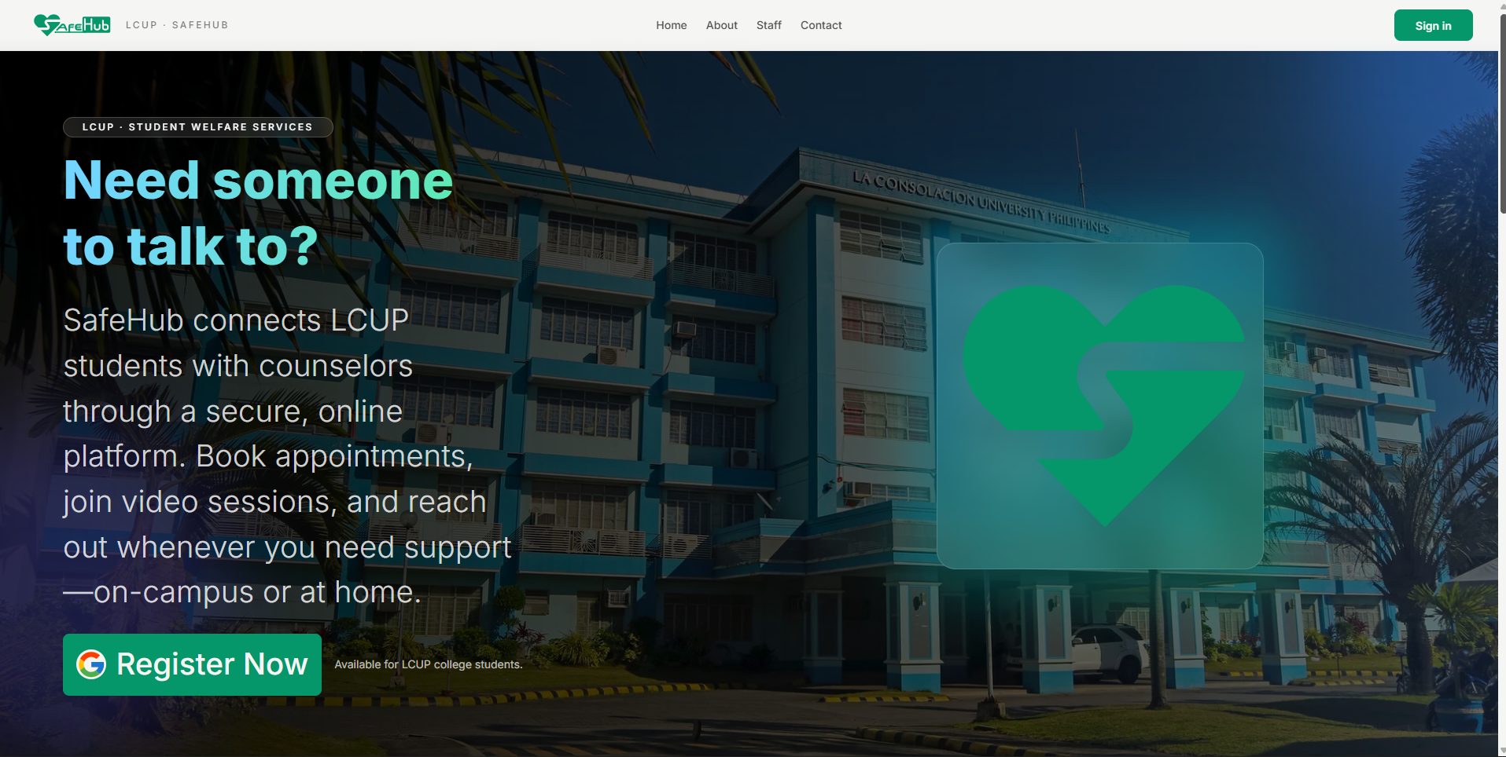
Figure 1. Landing Page

Part 2: Account Access
Signing In
- Open Safehub
- Click Sign In
- Select your LCUP G-Suite account.
- Wait for the system to authenticate your account.
Account Restrictions
If a non LCUP account is used:
- Access will be denied
- An error message will appear
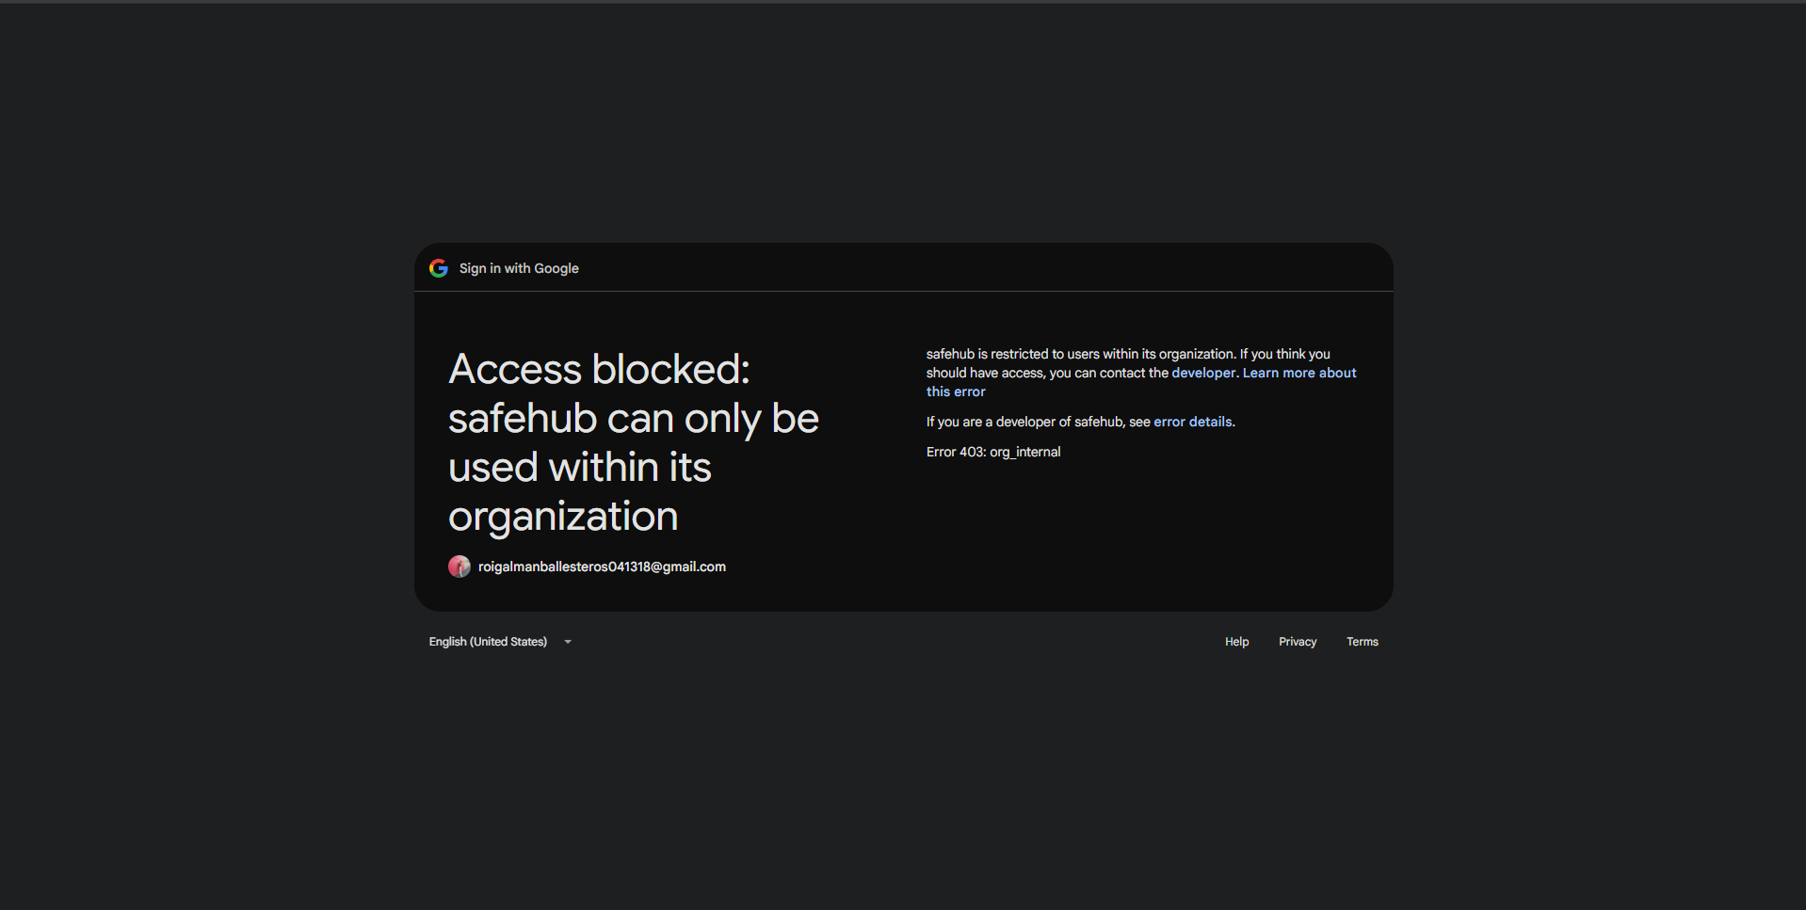
Figure 2. Account Restriction

Logging Out
- Open the Settings page or the dropdown menu at the top right
- Click Log out
- Confirm logout
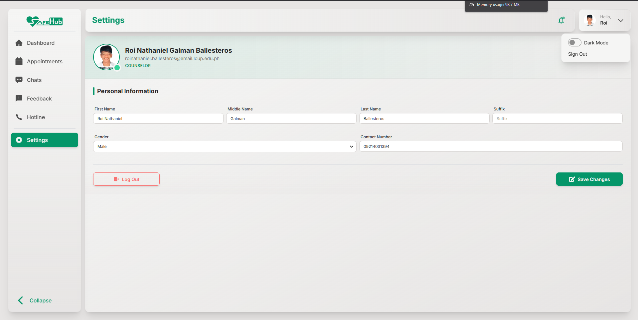
Figure 3. User Settings

Part 3: Home Dashboard
Dashboard Overview
The dashboard is the main interface of Safehub. It provides access to:
- Mood tracking
- AI chatbot
- Counseling appointments
- Notifications
- News feed
- Emergency hotlines
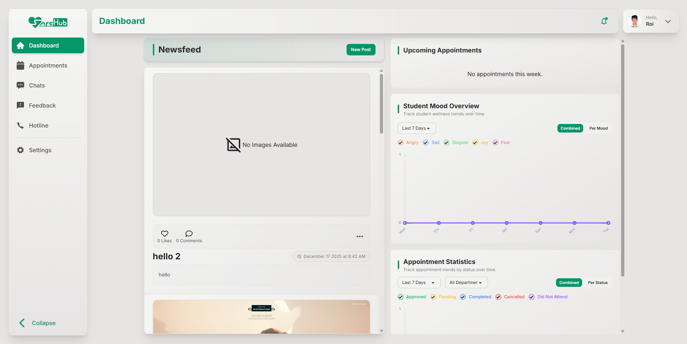
Figure 4. Dashboard

Part 4: AI Chatbot Support
Purpose of the AI Chatbot
- The AI chatbot provides immediate mental health assistance and guidance for students.
- Provide emotional support
- Suggest coping strategies
- Redirect users to emergency resources

Accessing the AI Chatbot
To use the Chatbot:
- Open the Chats section.
- Select Safehub AI.
- Type your message.
- Wait for the AI response.
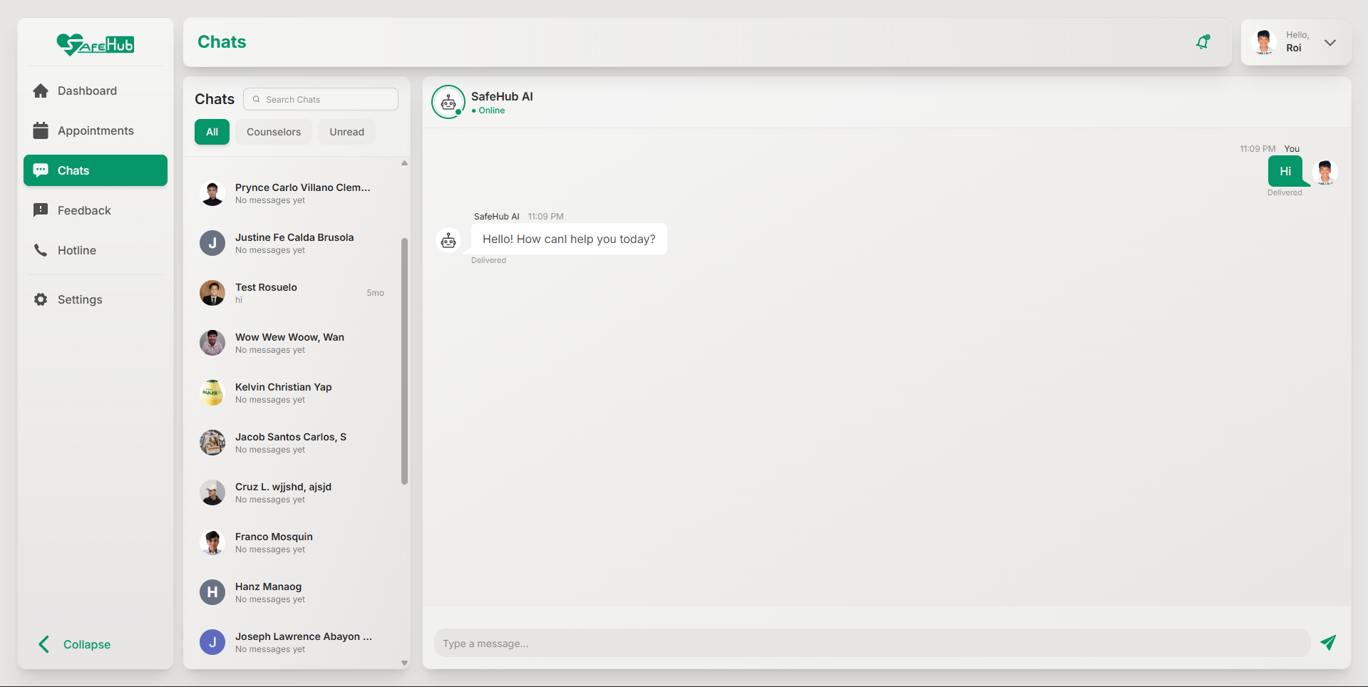
Figure 5. AI Chatbot

Part 5: Counseling Appointments

Purpose of the Appointment System
- The appointment module allows students to schedule counseling sessions online without visiting the SWS office physically.

Booking an Appointment
To create an appointment:
- Open the Appointment page.
- Click Book New Session.
- Fill out the appointment form
- Select:
  - Preferred counselor
  - Date
  - Time
- Accept the Terms and Conditions
- Click Submit
A confirmation message will appear once the booking is successful

Cancelling an Appointment
- Open the appointment details
- Click Cancel Appointment
- Confirm cancellation

Part 6: Mood Tracking

Purpose of the Mood Tracking
Mood Tracking helps students monitor their emotional well-being over time. The feature encourages self-awareness and emotional monitoring.
Recording a Mood
The Mood Tracking popup appears after login. Users may choose moods such as:
- Happy
- Sad
- Angry
- Fearful
- Disgusted
After selection:
- The mood is saved automatically.
- The dashboard graph updates.

Part 7: News Feed and Community Interaction

Purpose of the News Feed
The News Feed allows SWS staff to share:
- Announcements
- Mental health awareness posts
- School events
- Guidance resources

Viewing and Posting
Users can:
- Scroll through posts
- Like post
- Comment anonymously
- View images and updates
Admin and Counselor can:
- Create a new post
- Like and Comment anonymously

Create a Post
Admin and Counselor are allowed to make a post. To create a post:
- Open the News Feed or Posts section.
- Click Create Post or New Post.
- Enter the following:
  - Post title
  - Images
  - Context
- Click Publish.
The post will appear on student dashboards.
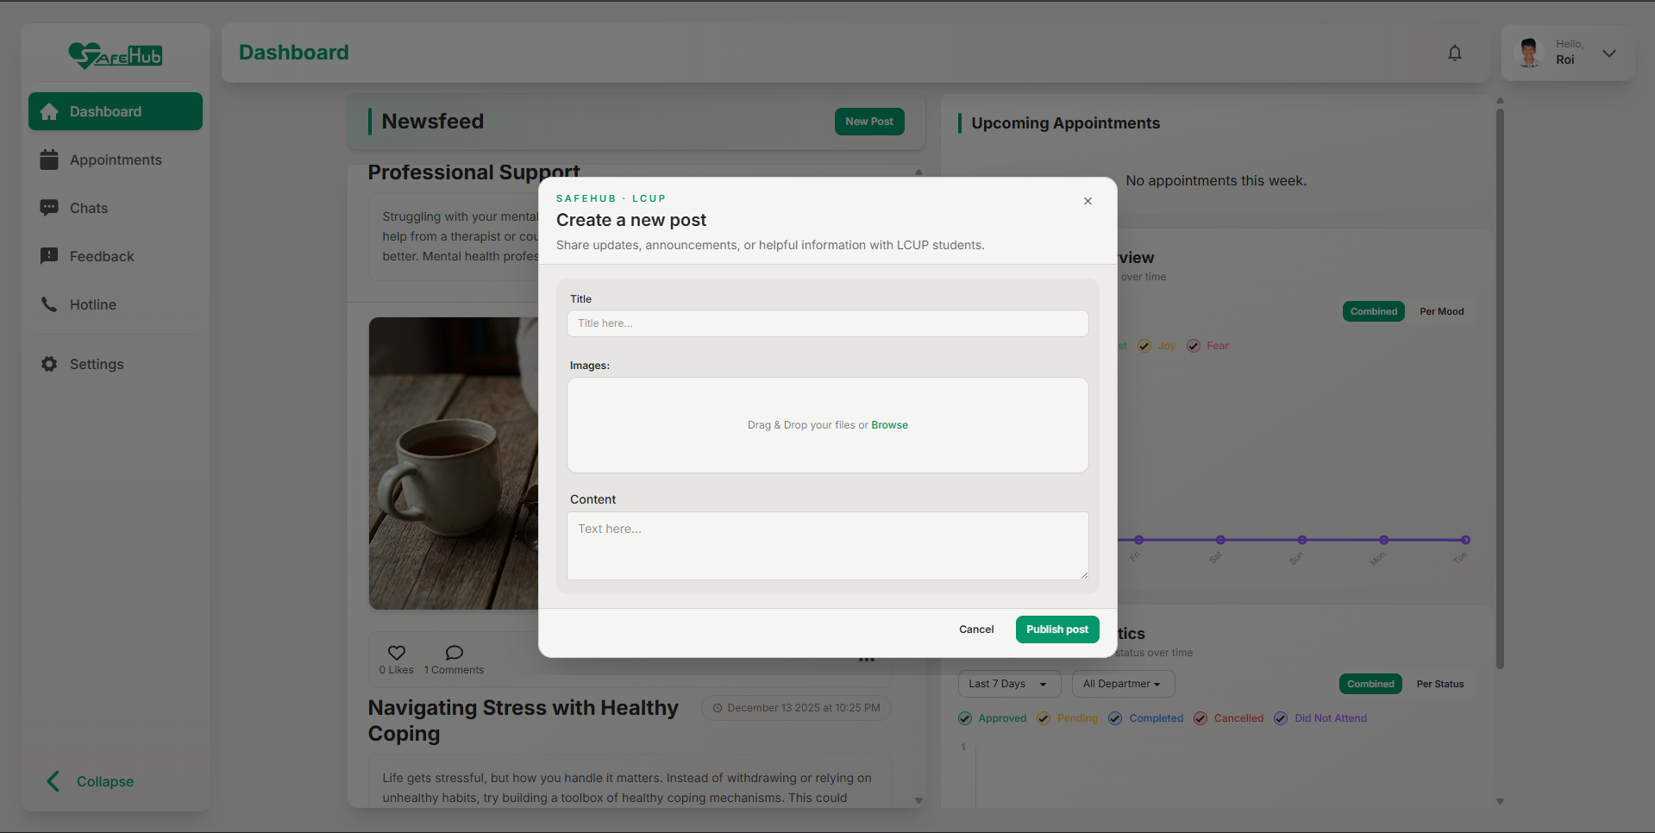
Figure 6. Post Creating

Editing a Post
Admin and Counselor are allowed to edit their post. To edit a published post:
- Open the newsfeed.
- Select the three dots under the image.
- Click Edit.
- Update the content.
- Save changes.
The updated version will appear automatically.
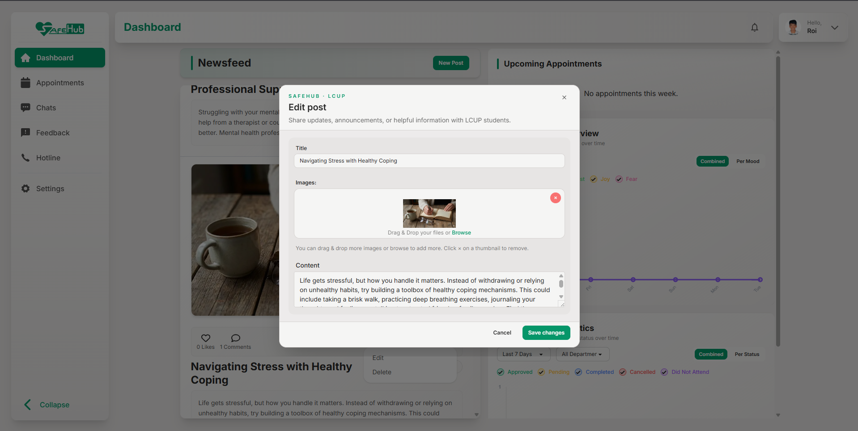
Figure 7. Post Editing

Part 8: Emergency Hotlines and Notification

Emergency Hotline Access
SafeHub provides access to important emergency hotlines.
Examples include:
- Mental health hotlines
- Crisis intervention contacts
- Emergency response services
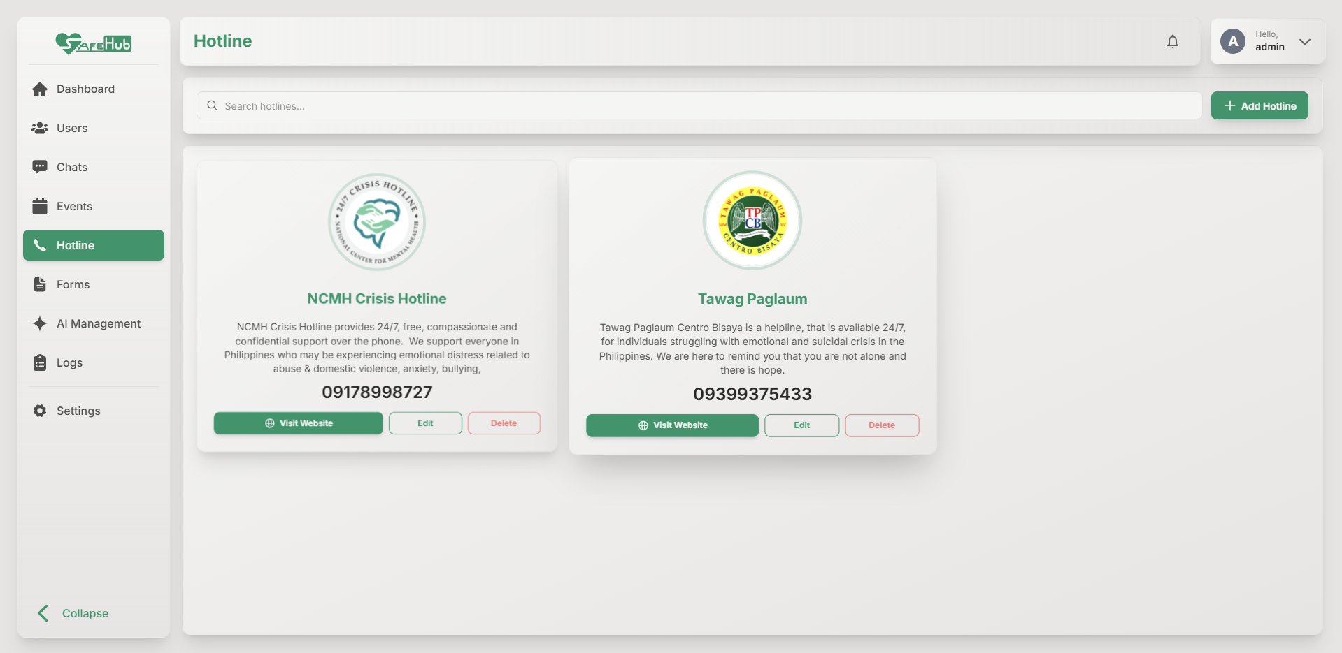
Figure 8. Hotline

Opening Hotline Links
To access hotline information:
- Open the Hotlines page.
- Select a hotline.
- Click the contact or website link.

Notifications and Alerts
Notifications help users stay informed about:
- Appointment updates
- System announcements
- Emergency alerts
- Counselor responses

Part 9: Troubleshooting

Unable to Login
Possible Causes:
- Incorrect account
- Non-LCUP email
- Internet connection issue
Solutions:
- Use an authorized LCUP account
- Refresh the page
- Check internet connectivity

Notifications Not Appearing
Possible Causes:
- Notifications disabled
- Browser permissions blocked
Solutions:
- Enable browser notifications
- Refresh the application
- Re-login to the system

AI Chatbot Not Responding
Possible Causes:
- Weak internet connection
- Temporary server issue
Solutions:
- Refresh the chat
- Reopen the chatbot
- Check internet connectivity

Appointment Submission Failed
Possible Causes:
- Incomplete form
- Missing required fields
- Terms and Conditions unchecked
Solutions:
- Complete all required information
- Accept the Terms and Conditions
- Try submitting again

End of Manual
- SafeHub was developed to provide LCUP students with a secure, accessible, and user-friendly digital mental health support platform.
- Through its AI-powered features, counseling appointment system, mood tracking tools, and emergency support services, SafeHub aims to improve student well-being while supporting the operations of the Student Welfare Services (SWS).
- The system encourages early mental health support, easier communication, and safer access to counseling resources within the LCUP community.

